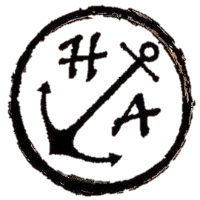
Breakfast Menu

Full English Breakfast
2 sausages, 2 smoked bacon, beans, hash brown, mushroom, tomato, 2 fried eggs, black pudding & toast
£10.00

Veggie/Vegan Breakfast
2 veggie sausage, beans, hash brown, 2 portobello mushrooms, tomatoes & toast (VG)
£9.00
Add 2 fried eggs £1.00 (V)

Breakfast Cob
Bacon, Sausage, Red Pepper & Squash Sausage (VE)
or Egg
£4.00
Extra items all 75p
Black Pudding, Egg, Tomato, Hash Brown
Mushrooms
Full Hot Drink Menu Available
The Bar is also open for Soft & Alcoholic Drinks
Breakfast Menu

Full English Breakfast
2 sausages, 2 smoked bacon, beans, hash brown, mushroom, tomato, 2 fried eggs, black pudding & toast
£10.00

Veggie/Vegan Breakfast
2 veggie sausage, beans, hash brown, 2 portobello mushrooms, tomatoes & toast (VG)
£9.00
Add 2 fried eggs £1.00 (V)

Breakfast Cob
Bacon, Sausage, Red Pepper & Squash Sausage (VE)
or Egg
£4.00
Extra items all 75p
Black Pudding, Egg, Tomato, Hash Brown
Mushrooms
Full Hot Drink Menu Available
The Bar is also open for Soft & Alcoholic Drinks

