
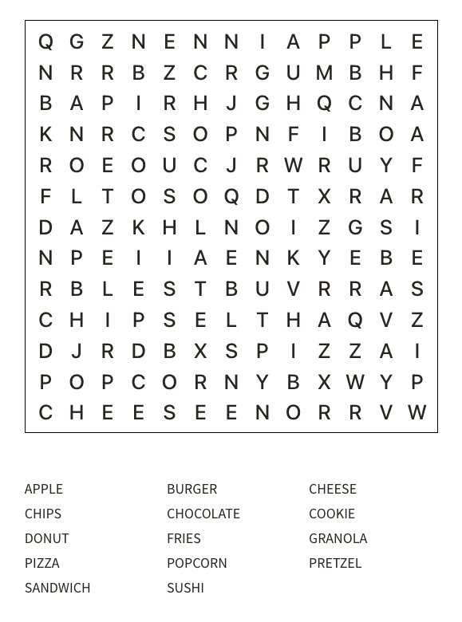
Kids Menu
Beef Burger £8.00
Cheese Burger £8.50
Southern Fried Chicken Goujons £8.00
Battered Cod £9.00
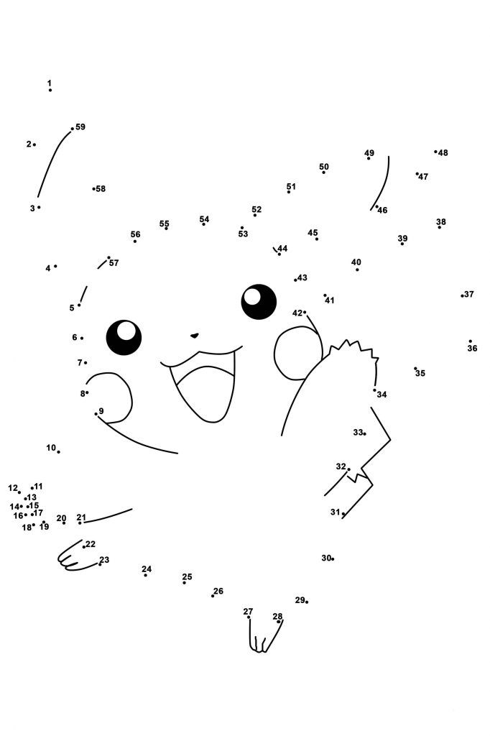
Sausages £8.00
Veggie Sausages (VE) £8.00
All above with a choice of fries or mash & peas or beans
Bolognese Linguine £8.00
DESSERTS
Brownie & Ice Cream with Chocolate Sauce £4.00
Ice Cream £3.50
2 Scoops of Ice Cream, with a choice of chocolate or strawberry sauce
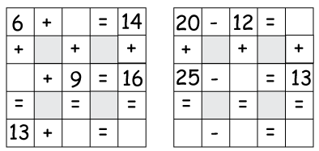
meal deal
Any Kids Main, Dessert & Drink for just £12
*Fruit shoot, squash, juice or small coke, diet coke or lemonade

